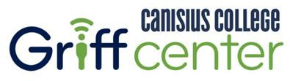

2001 Main Street Buffalo, NY 14208-1079
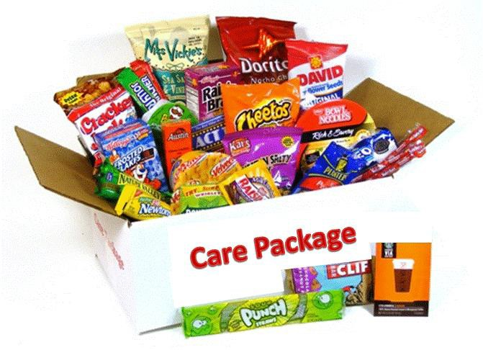

Dear Family Member,

Soon it will be time to send them off to school, and whether it’s your student’s first year or their last, it can be both an exciting and stressful experience. While you can’t be there with them, you can give them a boost and let them know you are thinking about them. Here’s how:

The Griff Center for Academic Engagement, in conjunction with the Higher Ed & Student Affairs Administration Program and the Women’s Lacrosse Team, is sponsoring and distributing welcome care packages for our students. For those who have never sent a college care package, the impact on your student is amazing. We guarantee your student will love them and the sales will help support the initiatives of these organizations.

We have designed a great set of welcome care packages to help kick off the school year. All you have to do is choose the package you want to send and fill out the free encouragement card we’ve included. Your card will be the first thing they see when they open their welcome care package. And every package includes a postage-paid postcard for your student to send you an old-fashioned update on school life. So, let’s get to it! Here are your choices:
The Ultimate Griff Welcome Package is the biggest and best care package and includes everything in the following 3 care packages --- 52 items in all! It’s the most popular package with our students and a great value.
- Our Natural Energy Welcome Care Package has 24 fortifying snacks that will help them to keep going as they adjust to the pace of college life including: Fiber One Brownie, Boulder Canyon All Natural Chips, Kellogg's NutriGrain
Cereal Bars, Taster’s Choice Instant Coffee Sticks, Heath English Toffee Bar, Skittles Original Fruit Chews, Frito Lay Smart Mix Baked Chips, Kellogg's Fiber Plus Bars, Emergen-C Drink Mixes, Frito Lay Whole Grain Sun Chips, Maruchan Instant Lunch, Mentos Mints, Nature Valley Oats ‘n’ Honey Bars, Wonderful Pistachios, Microwave Popcorn, Gardetto's Snack Mix and more!

- Our Traditional Welcome Care Package has a broad selection of 24 classic snacks and is the perfect complement to those first few hectic weeks of school. It includes: Nature Valley Almond Granola Bars, Miss Vickie's All Natural Chips, Kellogg's Single Serve Cereals, Kit Kat Wafer Bars, Pepperidge Farm Goldfish Crackers, Tootsie Pops, M&M's Milk Chocolate, Snyder's Pretzels, Breath Savers Mints, Nature Valley Sweet & Salty Bars, Twizzler Straws, Wrigley's Spearmint Gum, Chex Mix Traditional Snack Mix and more!

- Our I Need a Break Option includes 4 tried and true ‘take your mind off school’ items they are sure to love. Our gag item this semester is Noise Putty-- hard to comprehend but nonetheless amazing! Our game is a wooden triangle game. Next, there is a 4-color pen that’s great for underlining or just doodling. And last, but not least, a 3” mesh squeeze ball that will be used more than anything else in their room.

Ordering is easy. First, complete the attached order form below and select your care package. Next, write your message of encouragement on the enclosed card. Mail both in the pre-addressed envelope. Please respond by Thursday, August 23rd.

You can also order online at our store www.swaku.com/canisius. In addition to our Welcome packages, our store also offers specialty packages including Certified Organic, Gluten Free, Nut Free and Vegetarian care packages and discounted package plans for the entire school year.

Even if you can’t send a package, please send the card. Our primary goal is that no student feels left out!

Please call us at 800-929-8184 if you have any questions about this fundraiser. Thank you for your support.

Griff Center for Academic Engagement

Please detach and mail the Order Form below with your payment and message card.

Student Information Please mail (postmark) by August 23rd

Name:
For checks or money orders, please make payable to: SWAK University Services

Cell Phone: (optional) Credit Card #

Note – We will look up your student’s room info based on their name
CC Exp Date:
CC CSC Code

and having their cell # allows us to contact them with a text message Signature:
. Please mark which care package option you are ordering:

Parent / Relative Information The Ultimate Griff Welcome Package………………………….……….………. $59

Full Name: Street Address: City: State: Zip: Phone:
Our Natural Energy Welcome Package & I Need a Break Pack…...... $44 Our Traditional Welcome Package & I Need a Break Pack……….……. $38 Just our Natural Energy Welcome Package……………………….….………. $35
Just our Traditional Welcome Package……………….……………….……..… $29

** Email:
** For order confirmation Form NY-CAN-RW18

